1. Module輸出 Command dmesg –T  
     
     
   (TIMESTAMP / PARENT PID: / UID: / PROCESS: / STATE:)  
   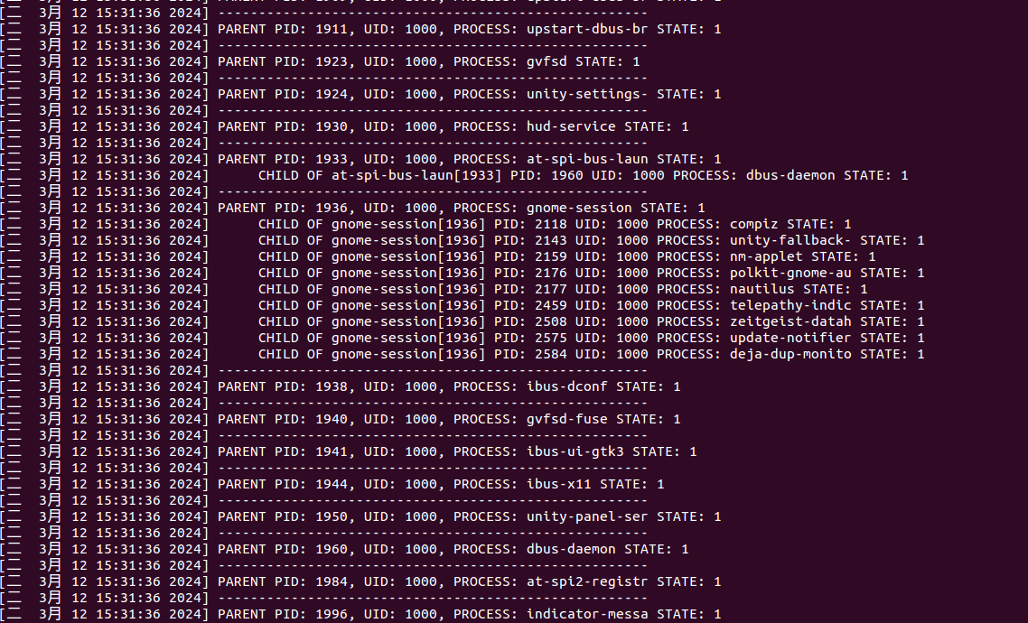

(範例片段圖片 完整在dmesg.txt文件中)

1. Command ps -ax -opid,uid,comm  
     
   (PID / UID / COMMAND)  
     
   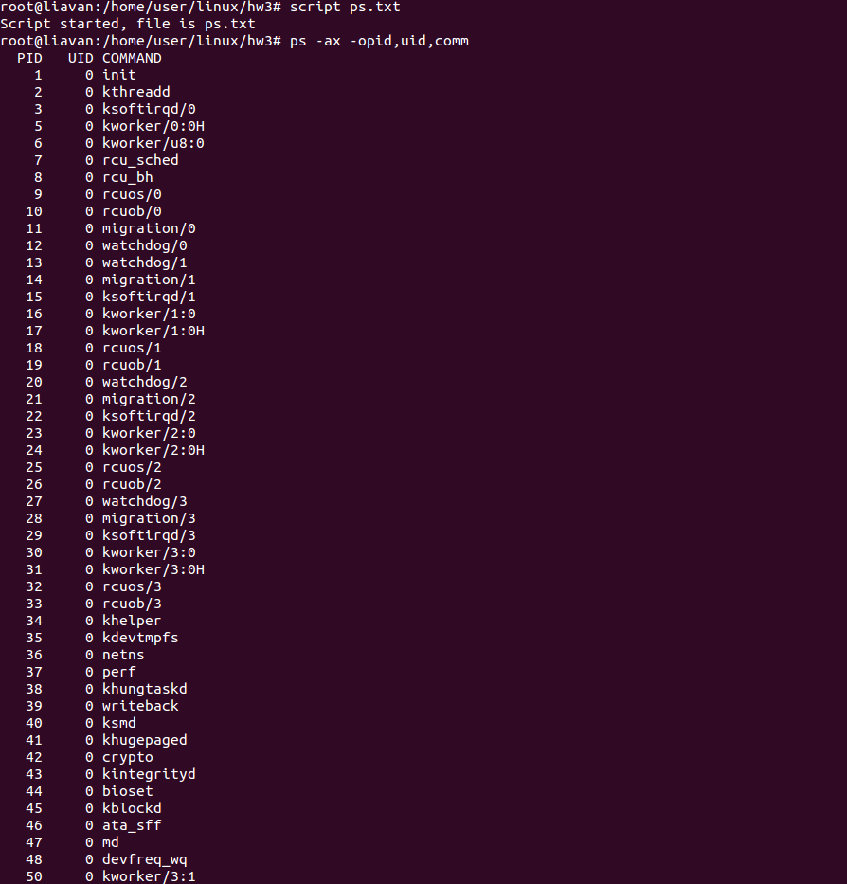  
     
   (範例片段圖片 完整在ps.txt文件中)
2. Source Code  
   